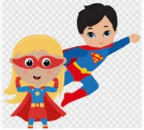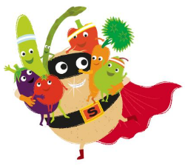****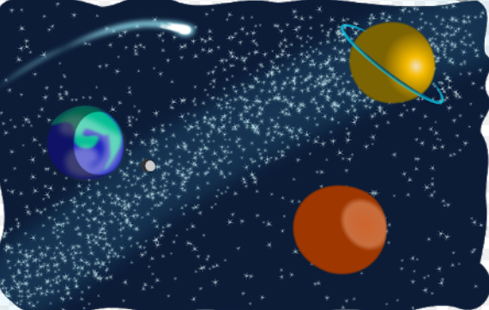

**Understanding the World**

* **What do we know about super heroes?**
* **How might real-life superheroes help us?**
* **What is in Space and how could we get there?**
* **Islam and Christianity – Special Times and Places.**

**Anderton Primary School**

**Summer Term 1**

**“Dare to Dream!”**

**Expressive Arts and Design**

* **Superhero Arts and Crafts – masks, capes and outfits.**
* **Space Arts and Crafts – rockets, planets and stars.**
* **Art work by Kandinsky – concentric circles.**
* **St Georges Day Arts and Crafts**

**Maths**

* **2D and 3D Shapes**
* **Building up numbers beyond 10.**
* **Adding more and taking away**
* **Doubling, sharing and grouping Even and Odd.**

**Personal Social and Emotional Development**

**This half term our focus will be “Perseverance”. We will discuss the importance of sticking at something even if we find it hard. We will talk about our own experiences and share fictional stories to aid our understanding. We will also discuss some of the dilemma drops and come up with sensible solutions to help them.**

**Communication and Language**

**This half term the children will be encouraged to listen and respond to others during discussions and conversations. They will be given opportunity to answer ‘how’ and ‘why’ questions about their experiences, will be encouraged to use their language to imagine and recreate roles in play situations.**

**Reading**

* **Super Tato – Sue Hendra**
* **Marvel Comics and Books**
* **Whatever Next – Jill Murphy**
* **How to catch a star – Oliver Jeffers**
* **Man on the moon – Simon Bartram**

**Writing**

* **Captions and labels about Superheroes and Space**
* **Story writing about Super Tato**
* **Non – fiction posters about space.**

**Physical Development**

**Children will take part in two PE sessions a week on Monday and Friday. In our PE sessions we will focus on practicing the 5 fundamental movements: running, hopping, jumping, throwing and catching.**

**The children will continue working on their fine motor skills through daily activities and provision in the classroom.**