French-

Draw some fruit and label it in English and French.

Religious Education-

Research the Qur’an. What is it? Why is it important to Muslims? What is it placed on? Where do you find it? Etc.

**You can email any videos, pictures or work to** [**Year3@anderton.lancs.sch.uk**](mailto:Year3@anderton.lancs.sch.uk) **or on dojo or seesaw.**

English-

Write a diary recount about your Christmas. Pick your favourite day and write all about it. The class will guess who has written it.

PE-

Make up a dance. It can be any type of dancing i.e, hip hop, break dancing, ballet, modern, tap. You can dance a solo, duet or group.

Art.

Create a printing piece of art work about something you enjoy i.e. football, music etc. If you need a piece of polystyrene, ask Miss Dervish.

History

Recreate Stonehenge. You can bake it, draw it, paint it, make it from junk modelling.

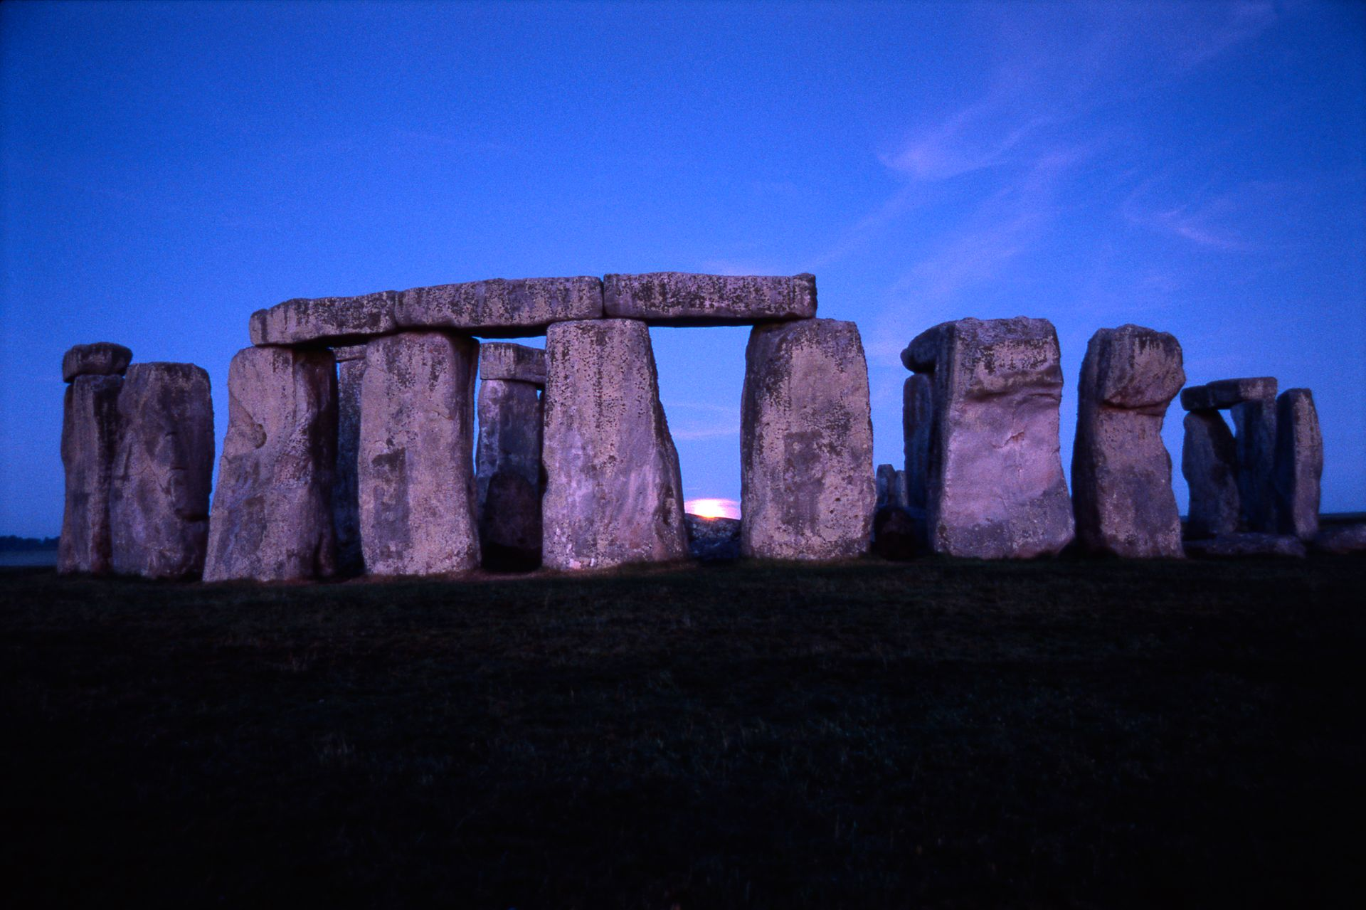

Maths-

**Times Table Rockstars-** Take part in the tournaments set by Miss Dervish.

**Division-** compete against your grown ups with division questions. Use your knowledge of 3, 4 and 8 timetables. Who can answer the quickest?

Computing

Make a poster highlighting the age restrictions for social media sites. Why do we have age restrictions?

Science-

Research different types of rocks. Write about their features and what they are used for.

**Year 3-**

**Extinct, Endangered, Existing**