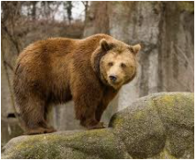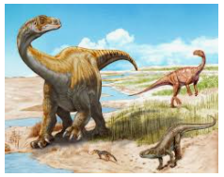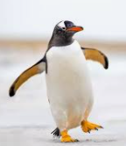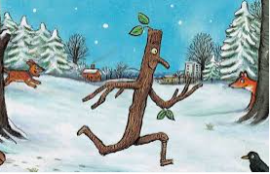 

**Anderton Primary School**

**Spring Term 1**

**Reception**

**Extinct, Endangered, Existing!**

**Personal Social and Emotional Development**

**This half term we will focus on kindness. We will share stories and real-life experiences about being kind. During circle time we will discuss and explore how it feels when people are kind to us. Children will be recognised for completed random acts of kindness.**

**Understanding the World**

* **E-Safety**
* **Winter and Seasonal changes**
* **Chinese New Year**
* **Dinosaurs and Fossils**
* **Animal Habitats**
* **Forest School**

**Expressive Arts and Design**

* **Winter crafts e.g 3D model igloos**
* **Dinosaur fossils**
* **Dinosaur Eggs**
* **Chinese New Year crafts**
* **Colour Mixing**

**Communication and Language**

**This half term the children till be encouraged to listen and follow instructions throughout the day. They will be encouraged to ask and answer questions appropriately using words such as how, why and when. Children will share daily story times where they will be encouraged to listen for a short period of time and answer questions about the text.**

**Reading**

* **Stick Man**
* **Lost and Found**
* **We’re going on a Bear Hunt!**
* **Harry and his bucket of Dinosaurs**
* **Non-fiction books about animals and dinosaurs**
* **CVC words and tricky words (Phonics)**

**Writing**

* **Words and captions about Winter, Animals and Dinosaurs**
* **Instructions**
* **Story Writing**
* **Menus and Food Lists**

**Maths**

* **Counting**
* **Recognising numbers**
* **Representing numbers (11-20)**
* **Addition**
* **Capacity**

**Physical Development**

**Children will take part in two PE sessions a week on Monday and Friday. In our PE lessons we will continue working on the 5 fundamental skills.**

**The children will continue working on their fine motor skills through daily activities and provision in the classroom.**