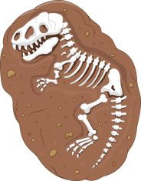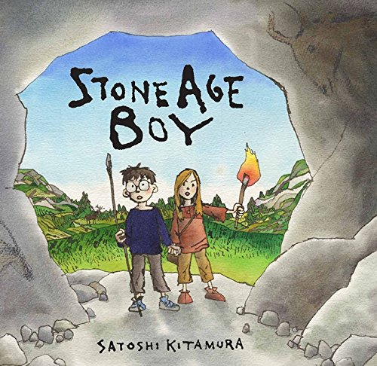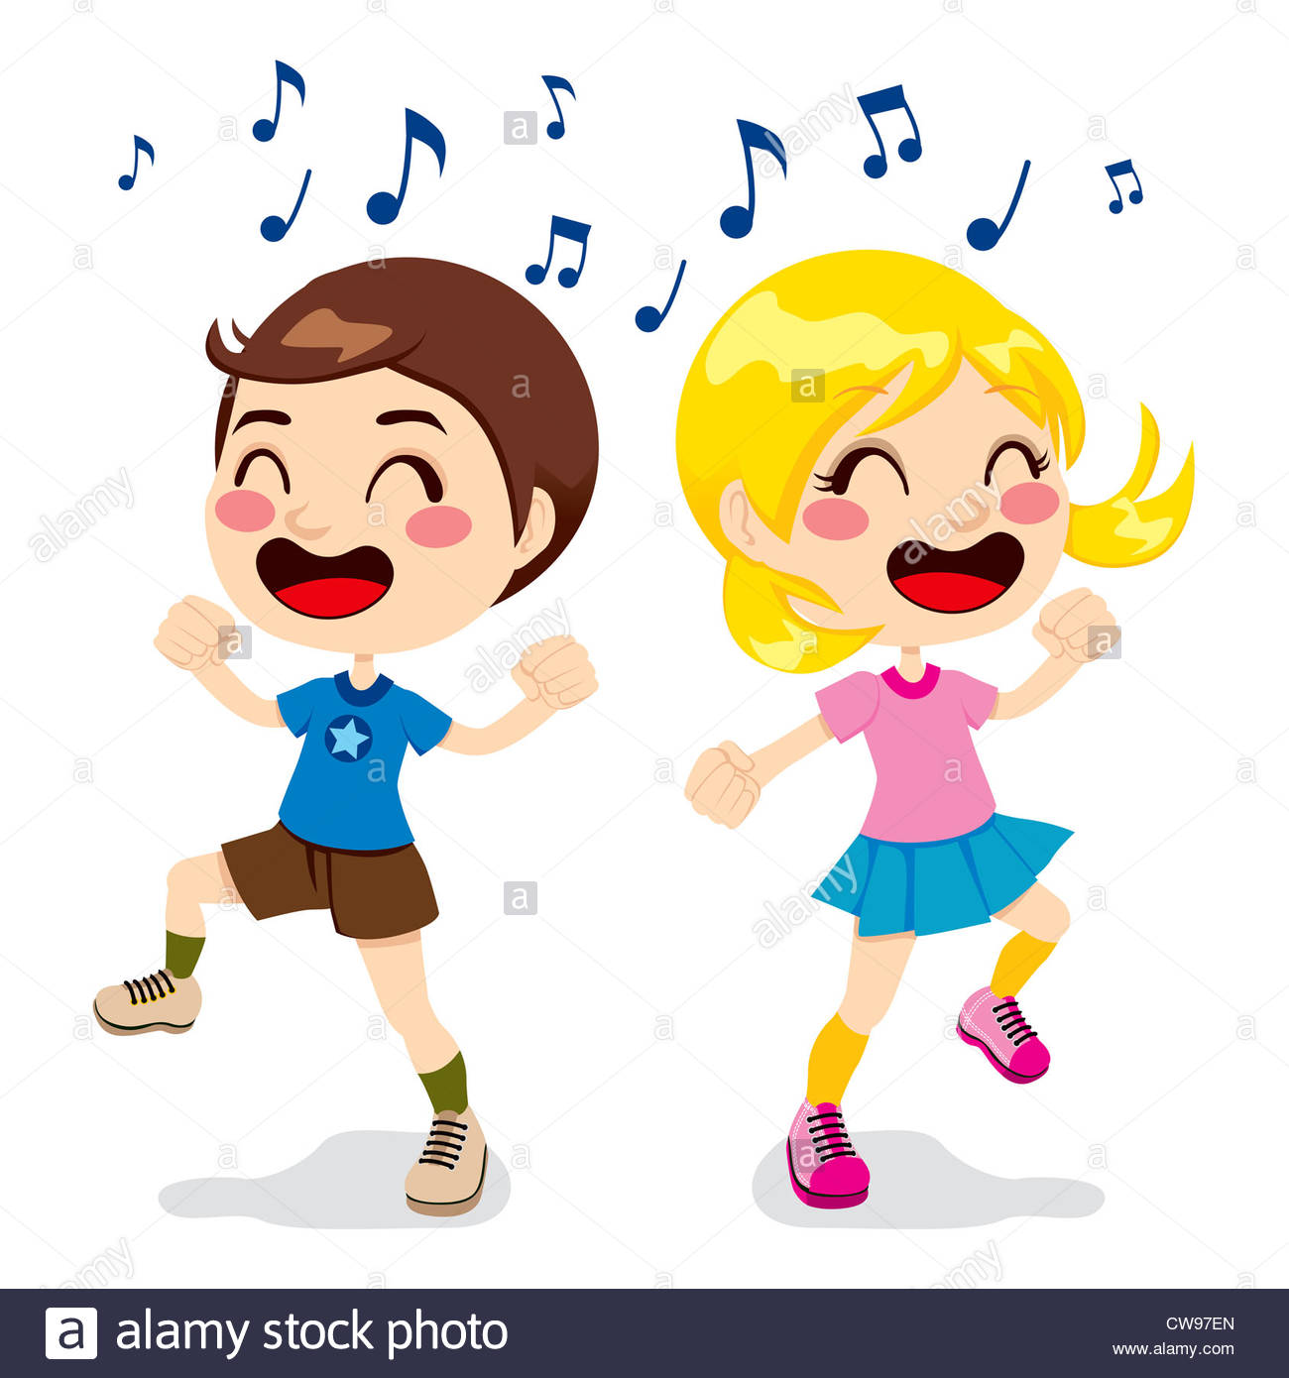****

**Maths**

Multiplication and division

Money

Statistics

Measurement and Length

Fractions

**Computing**

**Email**

We will be learning how to open and respond to emails using online address books.

**Internet Safety**

Year 3 will be learning about the importance of online age restrictions.

**RE**

**Islam**

We will be examining the origins and leadership of Islam, focussing on Tawid, Iman, Ibadah and Akhlaq. Children will consider the role model provided by Muhammad (pbuh) and to make links to role models in their lives.

**PSHE**

**Core Theme: Health and Well being**

We will be focussing on growing and changing. Looking at our achievements and what makes us special.

We will also be looking at how our body changes as we grow.

**Anderton Primary School**

**Spring Term 1**

**Year 3**

**Extinct, Endangered, Existing**

**Science**

**Rocks, Soils and Fossils.**

Year 3 will be comparing and grouping together different kinds of rocks on the basis of their appearance and simple physical properties. Describing how fossils are formed when things that have lived are trapped within rock.

**English**

**Novel as a Theme-**

The children will be writing their own story based on Stone Age Boy.

**Non-Chronological Report-**

We will be writing a non-chronological report on extinct animals.

**Poems-**

Children will be learning and performing poems about endangered species.

**PE**

**Dance**

Our dance will link with our Science topic all about rock. The children will experiment moving in various ways and will create a rhythmic circle dance.

**History**

**Stone Age to Iron Age**

Year 3 will be learning how things have changed over time through researching what it was like in the Stone Age and Iron Age.

**Art**

**Printing-**

The children will be designing their own fossil pictures, tracing them and printing a repeated fossil design.

**Music**

**The Dragon Song**

All the learning is focused around one song: The Dragon Song. Using imagination and working together as a class, creating our own performance of the song.