****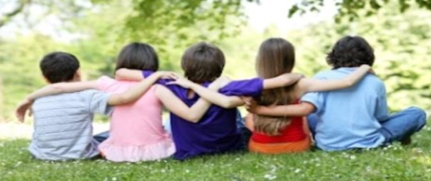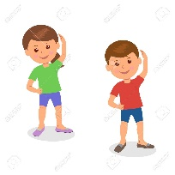

**PSHE**

**Core Theme: Friendship**

Children will be taking part in a range of activities looking at friendships and the way in which we treat each other.

**PE**

**Gymnastics** -

We will be learning different gymnastic positions, making a range of balances with a partner, focusing on trust and making sequences. We will also be learning how to roll and jump safely.

**English**

**Poem-**we will be making our own shape/calligram poem about Christmas.

**Fables-** we will be reading a range of fables for the children to write their own.

**Persuasive letter/poster-** Children will be writing a letter/ creating a poster to persuade children from school to come and listen to our poems.

**Science**

**Lights and Shadows**

The children will be learning about natural and man-made light sources and how we create shadows and reflections.

**History**

**The Local History**

We will be researching a range of local history facts including the story of local lad, Joe Davies of WWII

**Design Technology**

**Photo frames.**

The children will be researching different photo frames and the different types of materials used to make them. They will then plan, design and create their own photo frame.

**RE**

**Christianity God**

This unit enables pupils to examine the Christian belief. The focus is on the presence of God incarnate in Jesus. Opportunities are provided for pupils to explore evidence of God’s presence and humankind’s response to this and to link this with consideration of evidence of and response to examples of significant presence in pupils’ lives.

**Computing**

**Online Safety** The children will learn how to log on and the importance of keeping their usernames and passwords private.

**Touch Typing**- Year 3 will be learning how to touch type on the computers.

**Maths**

Recapping place value

Adding and subtracting

Multiplication and division

**Anderton Primary School**

**Autumn Term 2**

**Year 3**

**Lights, Camera, Action!**

**Music**

**Glockenspiels**

The children will be learning the language of music through playing the glockenspiel.